PROJECT PROPOSAL
LINE FOLLOWING ROBOT
TEAM A2 - SONILASH

GP118 – BASIC ELECTRICAL AND ELECTRONICS ENGINEERING
[Pick the date]

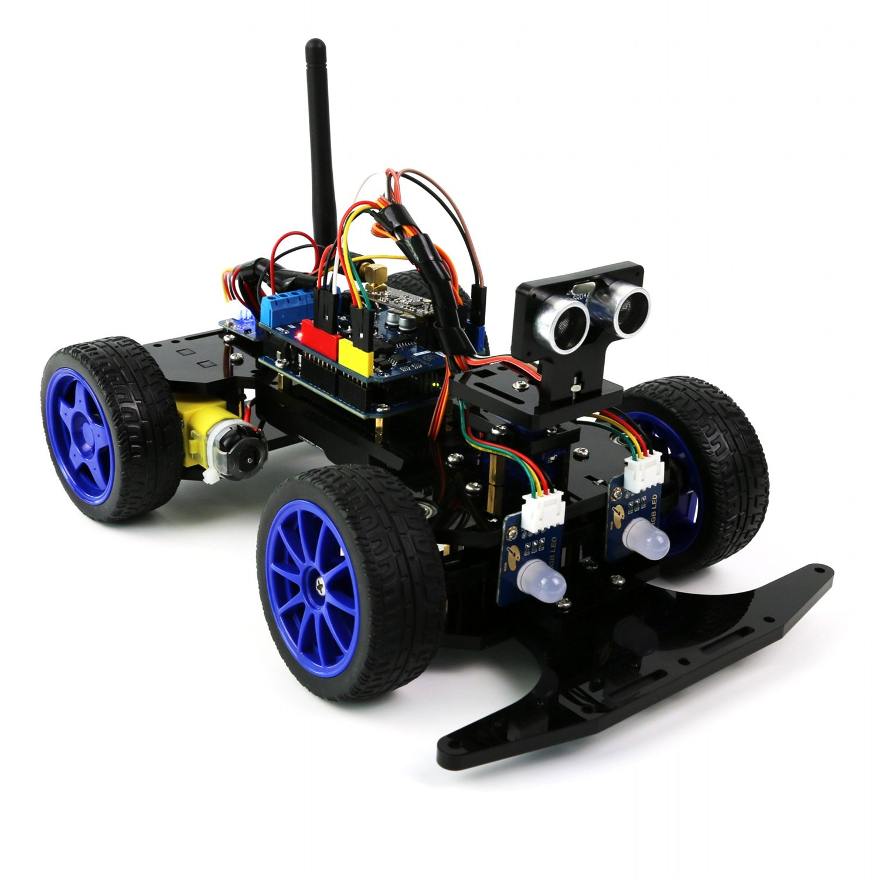

Project Overview
For Deeep-speed 2019, We’ve Been Tasked With the Creation of a Robot That Is Able to Follow a Preset Path (i.e. A Line Following Robot). The Challenge Here is to Program the Robot Such That It Completes the Track in the Shortest Possible Time and with the Highest Possible Accuracy. With This year’s Batch Given The Option To Program The Robot Using Arduino Or Some Other Digital System, We’ve Decided To Go With An Arduino Approach.

Problem Analysis
This Project Has Its Own Set Of Internal Challenges That Require Overcoming:
- Speed Control of the Robot.
- Differentiating The Colours Of The Path Upon Which The Robot Is Placed.
- Identification of Curvature in the Said Path.
- Turning Mechanism of the Robot (At the Curves And Intersections).
- Circuit Design(To Optimize Weight Distribution And Power Consumption, Hence, Improving Performance)
- Usage of the Arduino Board.
- Cost Optimization.

Project Cost
Component | Unit Price(LKR) | No of Units | Price
3 Wheel chassis | 1100.00 | 1 | 1100.00
IR sensor | 170.00 | 3 | 510.00
Aduino-Uno board | 1400.00 | 1 | 1400.00
Jumper Wires(M – F) | 6.00 | 10 | 60.00
Female DC pin | 47.00 | 1 | 47.00
4007 diode | 2.50 | 1 | 2.50
1K resistor | 0.50 | 4 | 2.00
LED | 3.00 | 10 | 30.00
L298 Motor Driver | 525.00 | 1 | 525.00
Switch | 25.00 | 1 | 25.00
Battery Rechargeble | 1200 | 1 | 1200.00
TOTAL |  |  | 4899.50

*cost are approximate values only. So it can be changed.

Team Details

Team leader
Name : - Alahakoon T.
Reg. No. : - E /17/008
Tel. No. : - 0755363320

Secretary
Name : - A.M.H.H. Alahakoon
Reg No. : - E/17/006
Tel. No. : - 0719777032

Presenter
Name : - Aluthge P.M.U.
Reg No. : - E/17/009
Tel. No. : - 0776976504

Members
Name : - A.M.Y.D. Alahakoon
Reg No. : - E/17/007
Tel. No. : - 0763971845

Name : - M. Amalan
Reg No. : - E/17/010
Tel. No. : - 0764574455

